Project Report Template

# 1 INTRODUCTION

1.1 Overview

Project Description

The Project aim is to provide real-time knowledge for all the students who have basic knowledge of Salesforce and looking for a real-time project. This project will also help to those professionals who are in cross-technology and wanted to switch to Salesforce with the help of this project they will gain knowledge and can include into their resume as well.

1.2 Purpose

The purpose of a customer relationship management (CRM) application for schools is to provide a centralized database that can help schools manage their relationships with various stakeholders such as students, parents, faculty, staff, and alumni. The CRM application can be used to collect and store data on these stakeholders, as well as track their interactions with the school over time.

# 2 Problem Definition & Design Thinking

2.1 Empathy Map

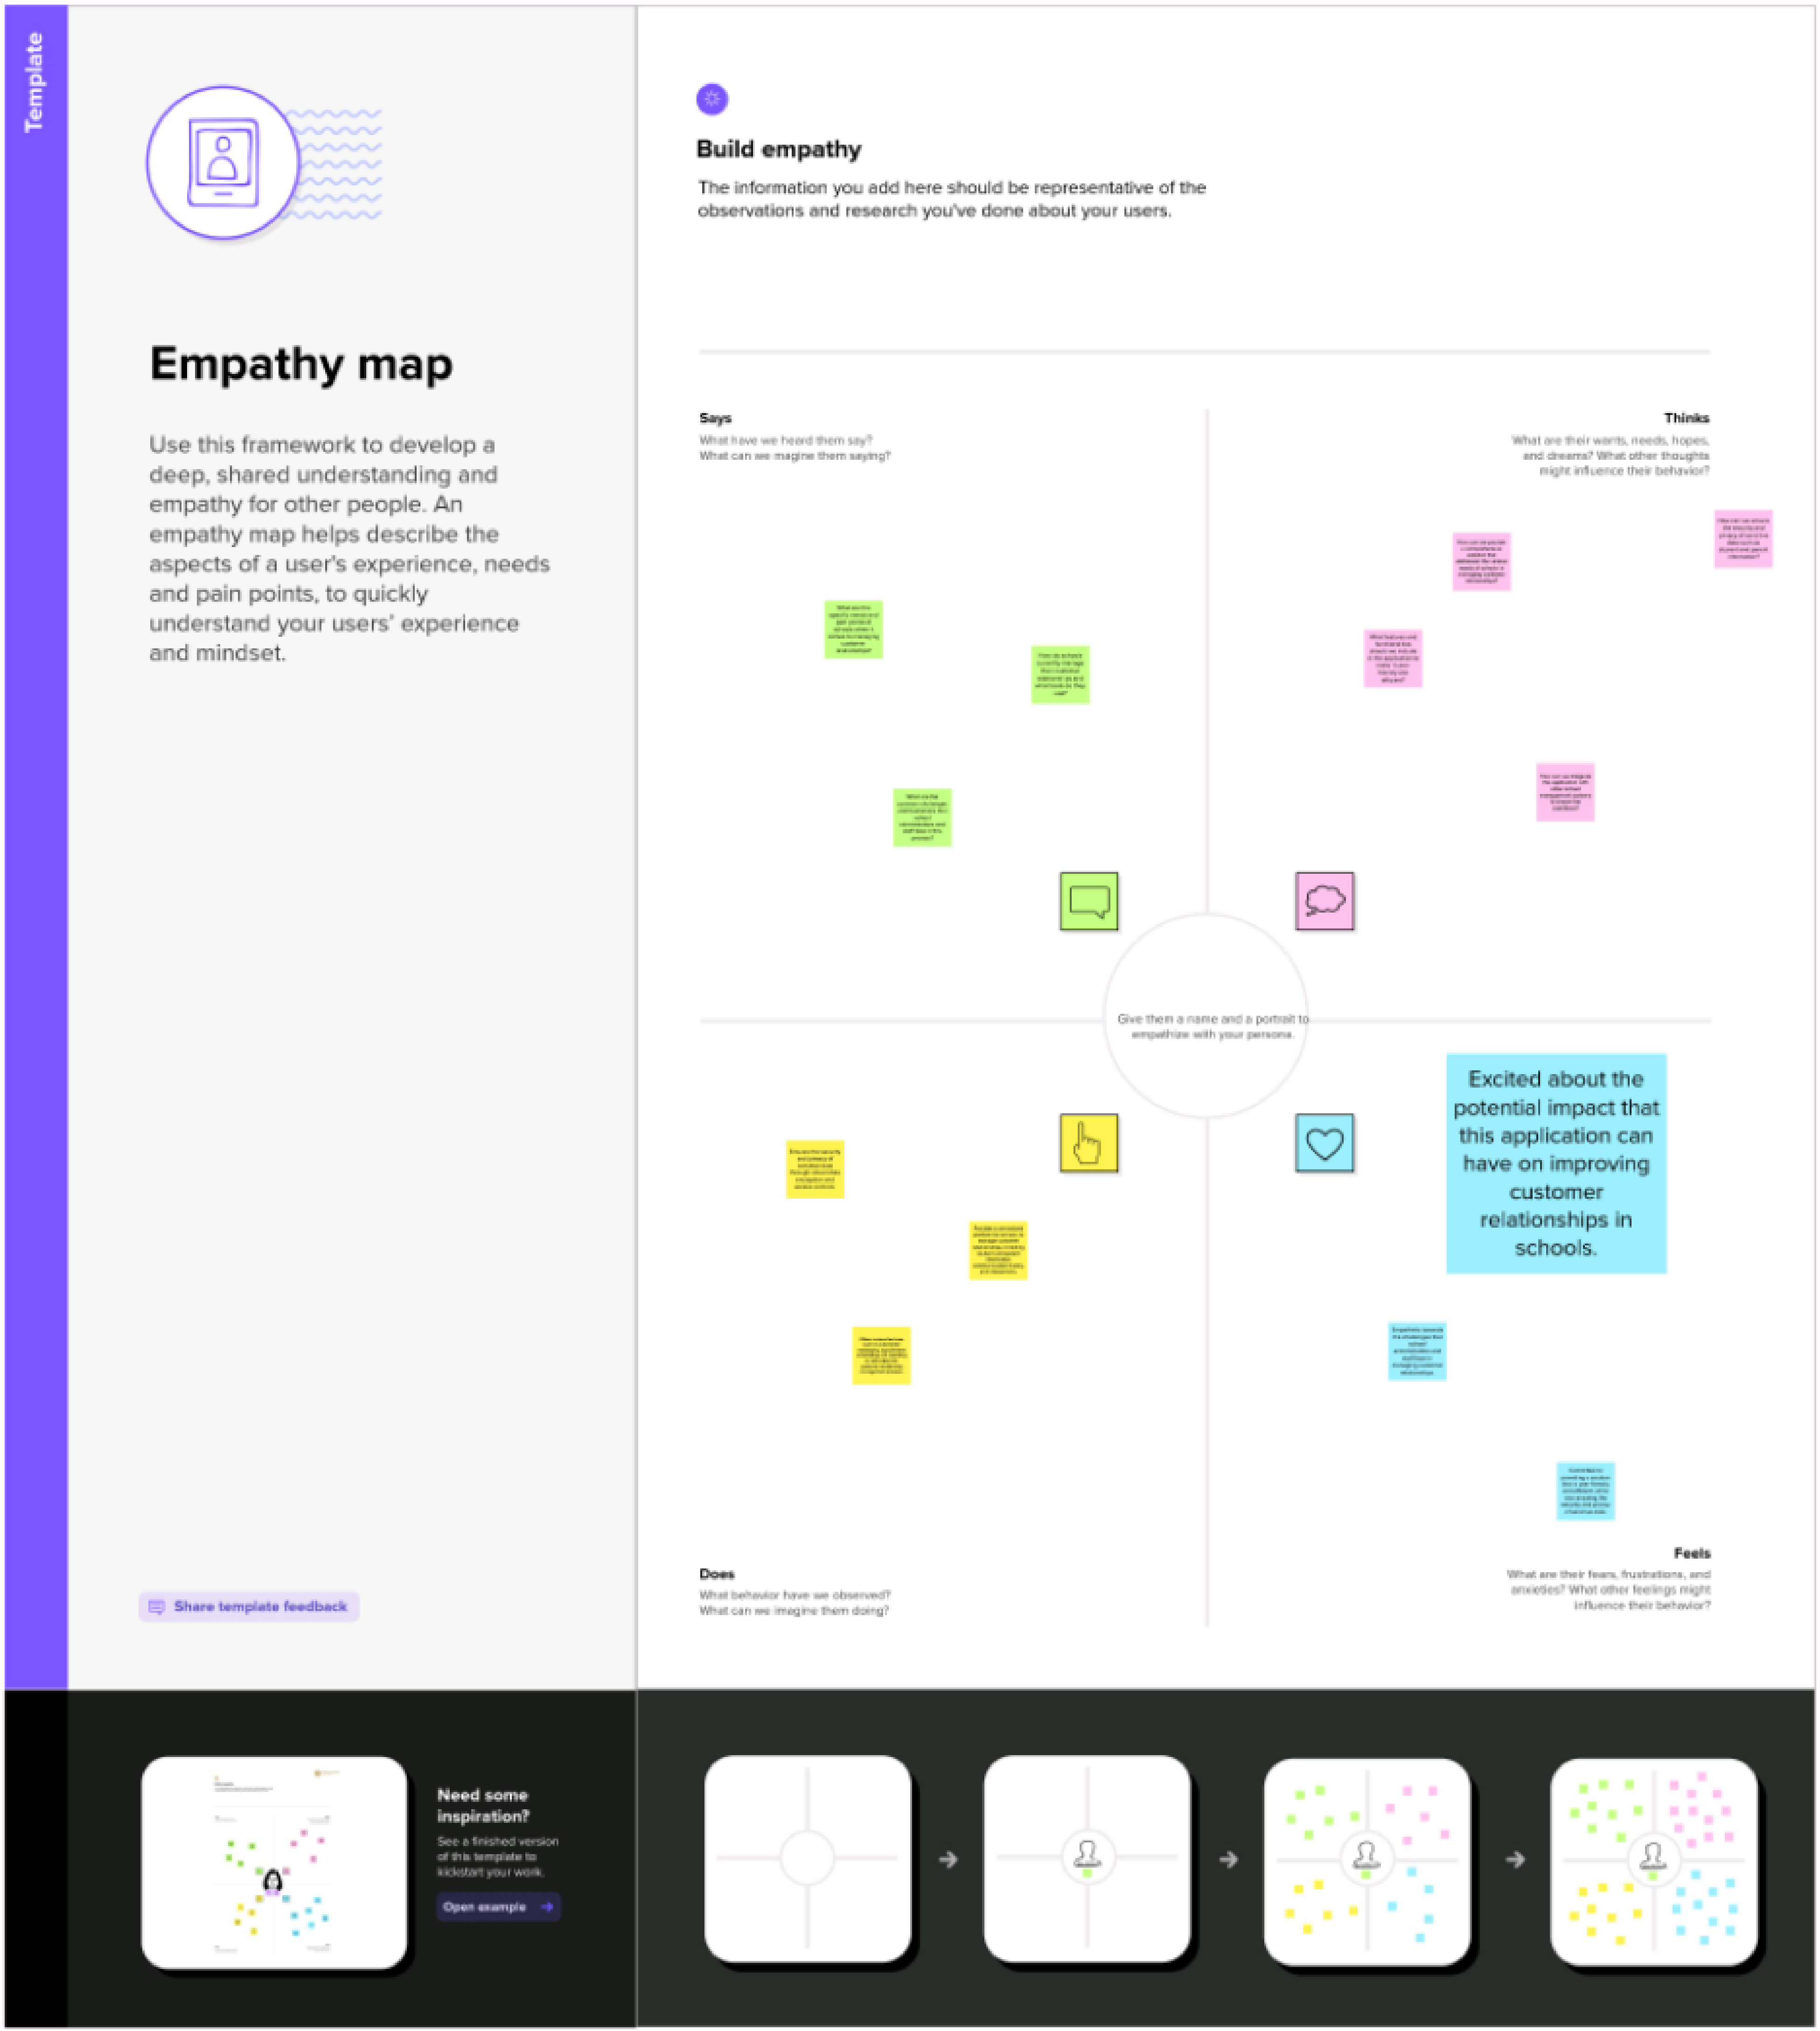

## 2.2 Ideation & Brainstorming Map

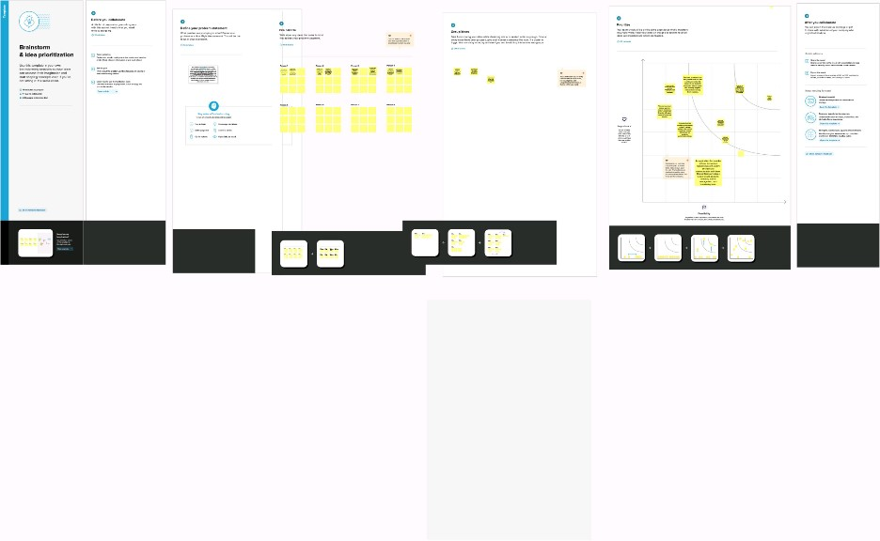

# 3 Result

3.1 Data Model

|  |  |  |  |  |
| --- | --- | --- | --- | --- |
|  | Object Name | Fields in the Object | | |
|  | Obj 1 |  | | |
| Field Label | Data Type |  |
|  |  |
|  |  |
|  | Obj 2 |  | | |
| Field Label | Data Type |  |
|  |  |
|  |  |

3.2 Activity and Screenshot

Trailhead Profile Public URL

Team Lead- https://trailblazer.me/id/trava12

Team Member 1 -https://trailblazer.me/id/vikns2

Team Member 2 - <https://trailblazer.me/id/vignm42>

Team member3: https://trailblazer.me/id/msvel2

# 5 ADVANTAGES AND DISADVANTAGES

Advantages ;

Improved Communication: CRM application can help schools to maintain better communication with students and their families. It can send automated notifications regarding schedules, announcements, and other important information, resulting in fewer missed opportunities and misunderstandings.

Efficient Data Management: A CRM application can help schools to organize and manage large amounts of data, including student information, academic records, and contact details. This can save time and reduce errors that can result from manual data entry.

Personalized Interaction: CRM application can provide personalized experiences to students and their families by keeping track of their interactions with the school. This can help schools to understand the needs of their students and families better, and offer customized services that meet their needs.

Streamlined Admissions: CRM application can make the admissions process easier and faster by automating tasks such as sending application forms, scheduling interviews, and sending acceptance letters. This can save time for both school administrators and families.

Enhanced Analytics: CRM application can provide schools with valuable insights into their operations and performance. They can track data such as student attendance, academic performance, and customer feedback to identify areas for improvement and optimize their resources.

# Disadvantages ;

Improved Communication: CRM application can help schools to maintain better communication with students and their families. It can send automated notifications regarding schedules, announcements, and other important information, resulting in fewer missed opportunities and misunderstandings.

Efficient Data Management: A CRM application can help schools to organize and manage large amounts of data, including student information, academic records, and contact details. This can save time and reduce errors that can result from manual data entry.

Personalized Interaction: CRM application can provide personalized experiences to students and their families by keeping track of their interactions with the school. This can help schools to understand the needs of their students and families better, and offer customized services that meet the needs

Cost: CRM applications can be expensive, especially for smaller schools with limited budgets. Implementing and maintaining a CRM system can require significant investments in hardware, software, and personnel.

Complexity: CRM applications can be complex and difficult to use, requiring extensive training for school administrators and staff. This can lead to resistance to change and a reluctance to adopt new technologies.

Privacy Concerns: CRM applications can raise privacy concerns among students and their families, especially when it comes to the collection and use of personal data. Schools need to ensure that their CRM system complies with data protection laws and policies.

Limited Customization: Some CRM applications may not offer enough flexibility to meet the unique needs of a school. This can result in a mismatch between the features of the system and the requirements of the school.

Maintenance and Support: Maintaining and supporting a CRM system can be a challenging task, requiring dedicated IT staff and ongoing updates and maintenance. Without proper support, the system may not function as intended, leading to frustration among users.

# 6 APPLICATONS

Donor Management: CRM applications can help schools manage donor information and relationships, including tracking donations, managing donor communication, and identifying potential donors.

Alumni Management: CRM applications can help schools manage alumni information and relationships, including tracking alumni engagement, managing alumni events and communication, and identifying potential donors and volunteers.

Event Management: CRM applications can help schools manage events, including registration, communication, and attendance tracking. This can help schools to improve event planning and increase attendance and engagement.

Customer Service: CRM applications can help schools to provide better customer service to students and their families by tracking their interactions with the school and providing personalized support.

Marketing and Outreach: CRM applications can help schools to improve their marketing and outreach efforts, including email campaigns, social media management, and lead tracking.

Overall, CRM applications can help schools to improve communication, increase efficiency, and provide better services toThere are several potential applications of CRM applications for schools, including:

Student Management: CRM applications can help schools

manage student information, including academic records, attendance, and contact details. This can help schools to provide personalized services and support to their students.

tracking, and communication with applicants and their families.

# 7 CONCLUSION

In conclusion, a CRM can offer many benefits to a school, such as improved communication, increased efficiency, better data management, improved student engagement, enhanced security, better reporting and analytics and streamline workflows.

# 8 FUTURE SCOPE

Connecting with buyers at the right time and through their preferred channels.

Determining what types of messages to send to customers and when to deliver them.

Prioritising and nurturing the right leads, ensuring a smooth hand-off from marketing to sales.

Predict future sales and budgets so you can plan accordingly.

Help your agents streamline the sales process—from initial contact to closing the deal.

Have client data centralised so that agents have access to real-time information and can deliver solutions quicker.

Offer your sales staff mobility options that work across browsers and devices.

Get insights into your customers’ journey so you can meet their expectations.

Provide mobile applications for your clients and staff no matter what device they’re using.

Offer customers an easy-to-use, self-service portal so they can be in control of their data and quickly find answers to their questions.